**Project Title: Egg Catcher Game in Java**

**Abstract**

The "Egg Catcher" game is a 2D arcade-style game developed in Java using the Swing and AWT libraries. It involves a bird dropping eggs from the top of the screen and a player-controlled boy catching them using a basket. The objective is to catch at least 5 eggs out of 10 to win the game. The project demonstrates fundamental concepts in Java programming, graphical user interface (GUI) development, event handling, and audio integration. The game incorporates mouse-based controls and sound effects to enhance user engagement.

**Introduction**

This project is developed as a part of the final capstone project to showcase the skills and knowledge acquired in Java programming and game development. The Egg Catcher game is inspired by classic arcade games and provides an interactive platform for understanding GUI elements, object movement, collision detection, and multimedia handling in Java.

**Objectives**

* To create an interactive Java game.
* To implement real-time graphics using Java Swing and AWT.
* To handle user input via mouse controls.
* To integrate audio for game events.

**Prompt Used:**

Create a Java program for an egg-catching game. The game should feature the following elements:

1.Background: Design a scenic background that includes a tree and a clear sky.

2.Characters: A basket which can move left and right. Eggs dropped at random intervals.

3.Game Mechanics: Implement a scoring system that awards points for each egg caught . Include a timer that counts down to increase the game's challenge.

4.Sound Effects: Add sound effects for catching an egg (e.g., a 'ding' sound).Include background music that plays throughout the game.

5.User Interface: Display the score and timer on the screen. Ensure that the controls are intuitive (e.g., use arrow keys for movement).

6.Game Over Condition: Define a game over condition, such as the timer reaching zero or a certain number of missed eggs. Ensure that the code is well-structured, commented, and includes error handling for smooth gameplay. Additionally, provide instructions on how to compile and run the game.

**Scope**

The game is designed as a desktop application and is compatible with any system that has Java installed. It serves educational purposes and showcases core programming skills.

**Game Description**

**Game Objective**

The player aims to catch at least 5 out of 10 falling eggs using a basket controlled by the mouse. If successful, the player wins; otherwise, the game ends with a loss.

**Rules**

* Eggs fall one at a time from a random horizontal position.
* The player moves the basket left or right using the mouse.
* If the basket catches the egg, the score increases.
* If the egg hits the ground, it's considered a miss.
* The game ends after 10 eggs have dropped.

**Functionality**

* Mouse-based movement for the basket.
* Randomized egg drop positions.
* Score tracking and win/loss display.
* Sound effects for catching and missing eggs.

**Code Structure and Implementation**

**Tools & Technologies Used**

* **Language:** Java
* **IDE:** IntelliJ IDEA / Eclipse
* **Graphics:** Java Swing & AWT
* **Audio:** Java Sound API

**Main Classes**

* EggCatcher: Main class implementing game logic and GUI

**Key Functions**

* paintComponent(): Draws the background, egg, and basket
* actionPerformed(): Moves the egg and handles game logic
* mouseMoved(): Controls the basket position based on mouse
* loadSound(): Loads audio files for catch and miss events

**Resource Files**

* background.png: Contains tree, bird, and boy
* egg.png: Image of an egg
* catch.wav: Sound for a successful catch
* miss.wav: Sound for a missed egg

**Screenshots & Diagrams**

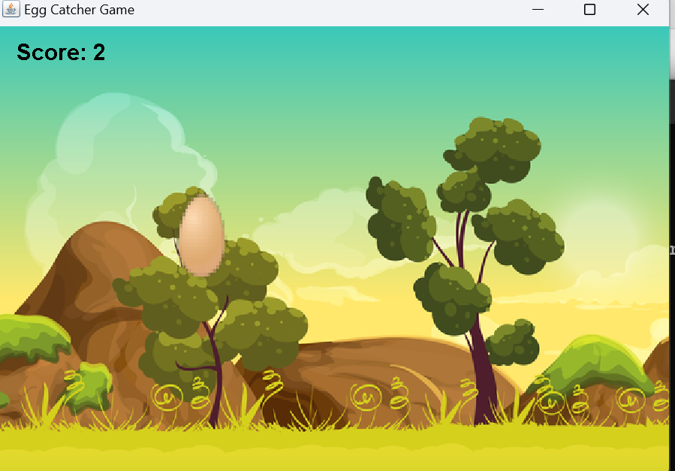

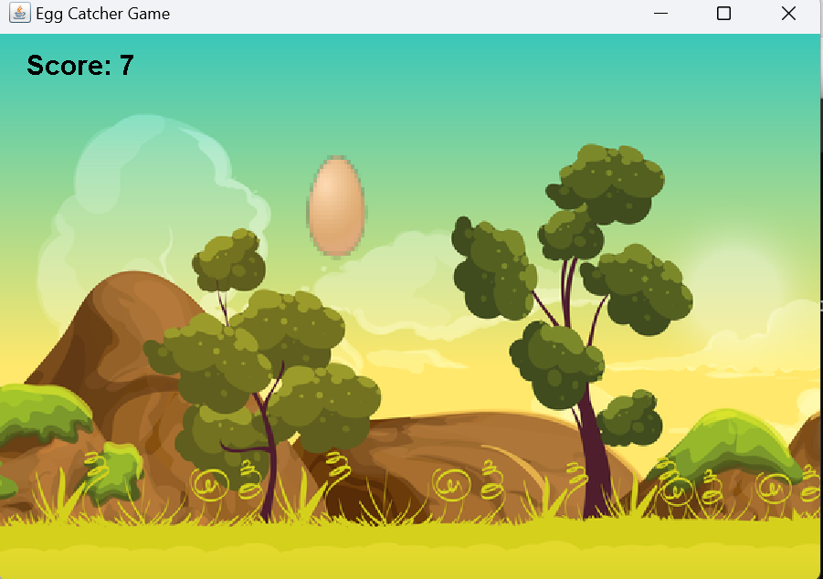

**Conclusion**

This capstone project successfully demonstrates how to develop an interactive GUI-based game in Java. Through the Egg Catcher game, we implemented fundamental game mechanics, multimedia integration, and user interaction. The project not only enhanced technical knowledge but also problem-solving and debugging skills. The final outcome is a fully functional Java game packaged as a runnable .jar file.

**References**

* Oracle Java Documentation
* Stack Overflow Discussions
* <https://docs.oracle.com/javase/tutorial/>
* <https://freesound.org/>
* <https://opengameart.org/>

**Appendix**

* GitHub Repository: https://github.com/Sudhauptor/EggCatcherGame.git
* Instructions to Run:
  + Compile: javac EggCatcher.java
  + Run: java EggCatcher
  + Package: jar cfm EggCatcher.jar manifest.txt EggCatcher.class resources/